PERSONAL INFORMATION
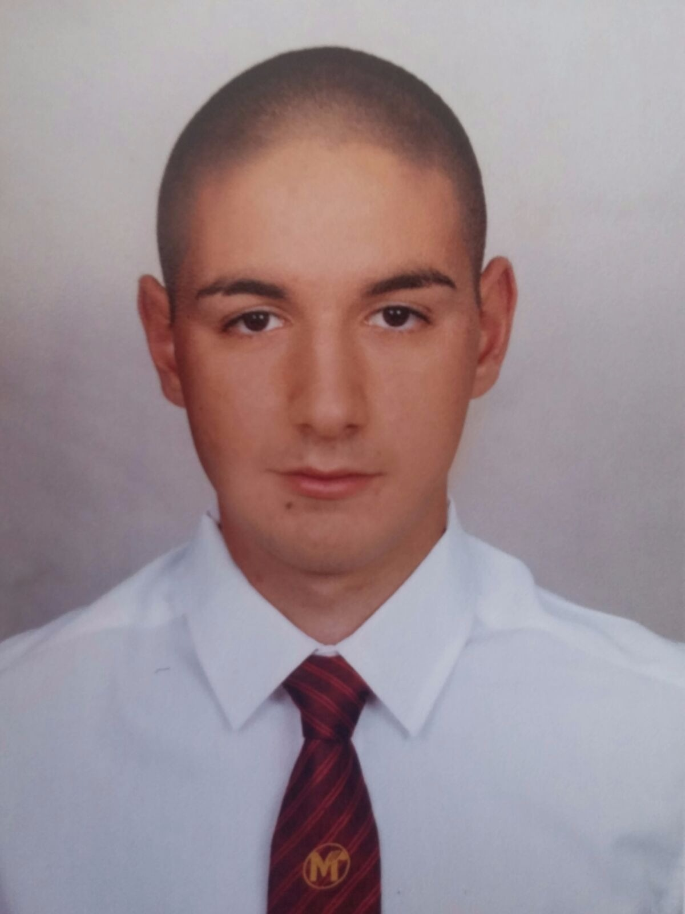 | Petar Savov Sabev    72 “Svoboda”, Plovdiv city, 4000, Bulgaria

+359 899 10 3535


psybev@abv.bg

 | http://pepochko.com/
 | Sex Male | Date of birth 19/05/1998 | Nationality Bulgarian

EDUCATION AND TRAINING

1/10/2016 – 30/11/2016  15/09/2016 – 2016  5/03/2016 – 5/05/2016  15/09/2015 - 30/06/2016  15/09/2013 – 2016 | Training course at Java Script in CodiCamp  Training course at PHP in Viscomp Ltd.  Front End Basic course in CodiCamp  Training course at Web Design in Web Host Face  Model High School of Mathematics

PERSONAL SKILLS

Mother tongue(s) | Bulgarian
Other language(s) | UNDERSTANDING |  | SPEAKING |  | WRITING
Other language(s) | Listening | Reading | Spoken interaction | Spoken production
English | B1 | B1 | B1 | B1 | B1

Computer skills | JavaScript  HTML5 & CSS3  GIT  Bootstrap  Adobe Photoshop  Adobe Illustrator  Good command of Microsoft Office™ tools  Software and Hardware

